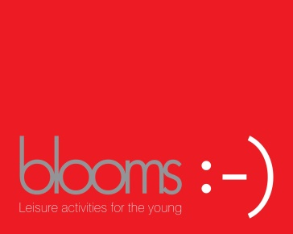
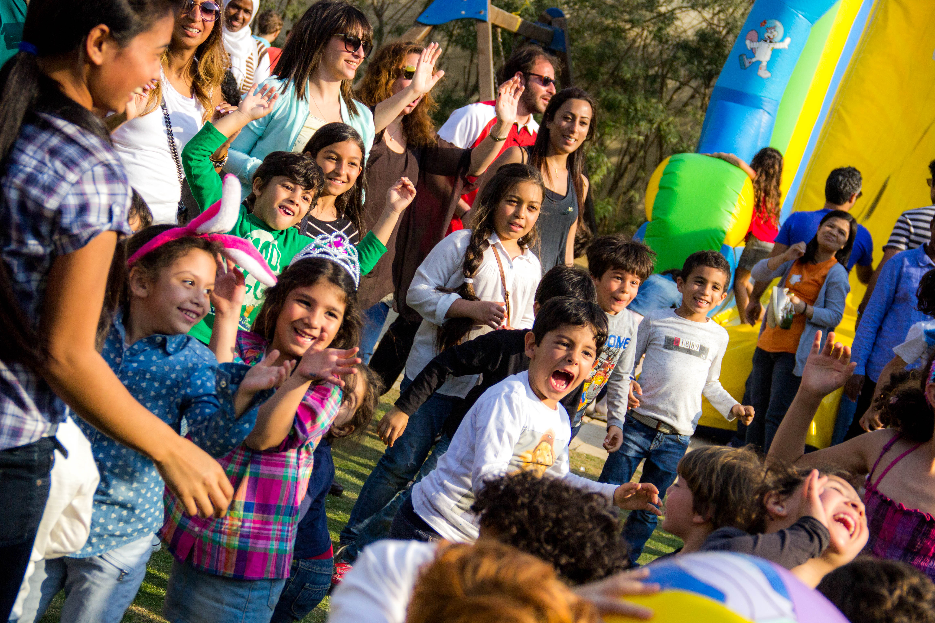
Birthdays 2017

Dear Sir/ Madam,

As per your request, Blooms Egypt is presenting you with a proposal for running the entertainment program of your child’s Birthday Party

Warm regards,

Blooms Egypt
Office: (+2) 02 2415 2411
E-mail: info@bloomsegypt.com
Facebook group: Blooms Egypt

Executive Summary
Blooms Egypt will be running the family entertainment program at your child’s Birthday Party. Please choose the activities & items you need from the list below and confirm back through e-mail. Once you confirm, we will then respond with a final e-mail to confirm that all the items you chose are available on the date requested & then payment is made within 24 hours of receiving our final confirmation e-mail.
Proposed Quote
The fees include:
# | Description | Price | Picture
 | Live Circus Show (All ages)  30 min. Show  - Magician  - Chinese Plates Spinners & Jugglers | 3,100EGP | 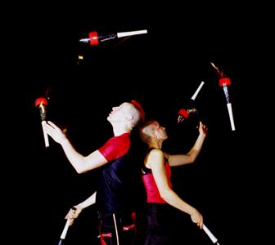
 | Interactive Family Activities (60 min.)  - All the materials needed  - Assistants  - Music  Must add the sound at the bottom of the list.  Click here to see a video | 9,610 EGP  For 40 children only. Please add 75 L.E for every extra child. | 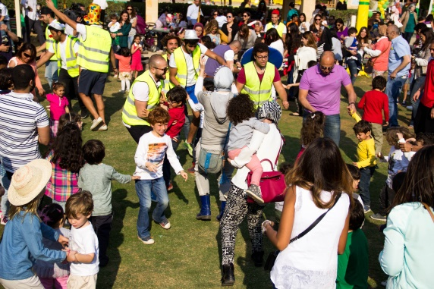
 | Arts & Crafts Stations (All Ages)  Client to choose 2 of the following crafts :  - Cement Coloring  - Crafts Making  - Origami  - Clay Making  The stations will be open for 1 hour or until the materials run out whichever happens first. | 4,710 EGP  Includes: All Materials for 25 children  Doesn’t include Tables & Chairs for children to sit on. If you would like to rent our tables & chairs please see the item later on in the list. | 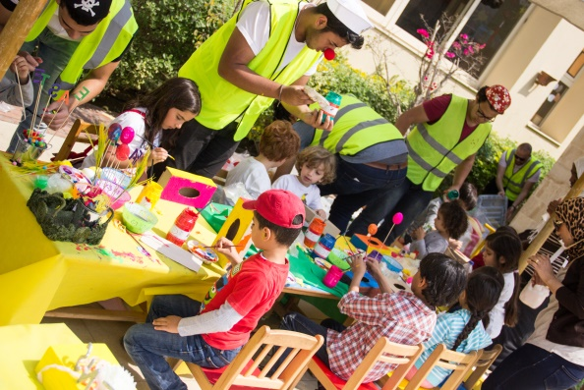
 | Face Painting | 1,400 EGP  For 30 children only. Please add 20 L.E for every extra child. | 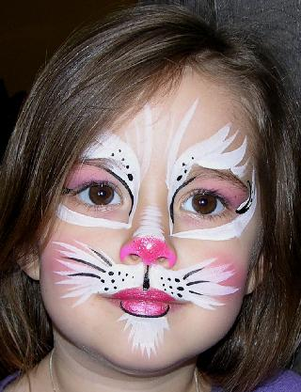
 | Bungee Trampoline | 2,400 EGP | 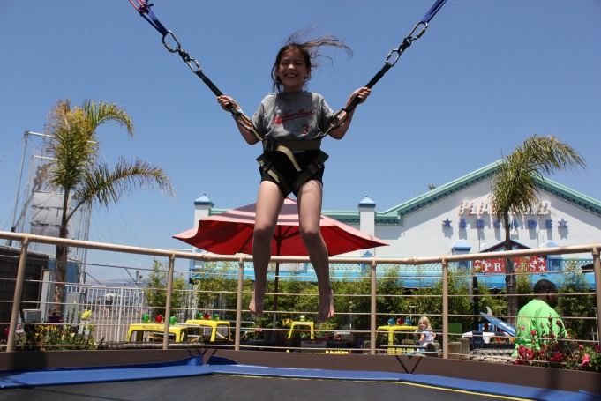
 | Bouncy Castle | 2,300 EGP | 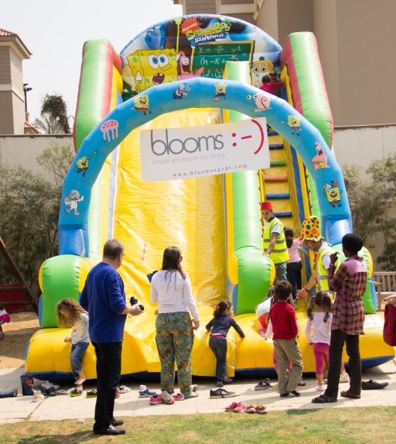
 | Balls Pool | 950EGP | 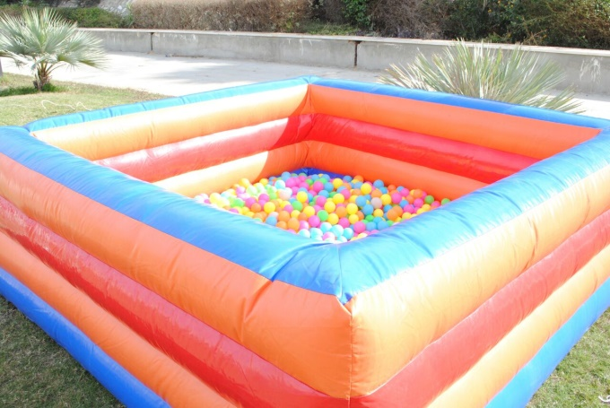
 | Bouncing Castle & Slide | 2,100 EGP | 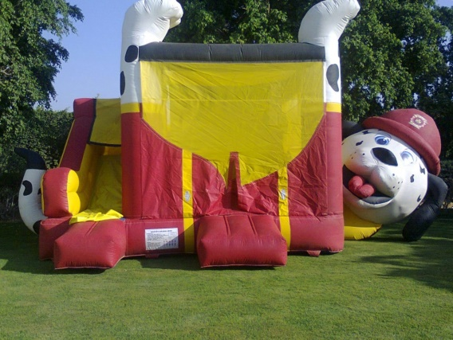
 | Characters Meet & Greet (All the family)  We will have a meet & greet session with Barney,  This is a 15 min show.  Must add the sound at the bottom of the list. | 3,600 EGP  Includes: Barney Character costumes, music. | 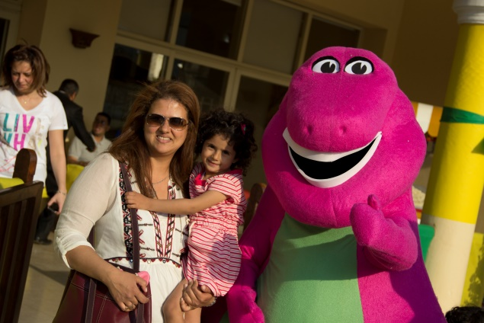
 | Pop Corn  For 50 children | 1,100 EGP  For 75 children only. | 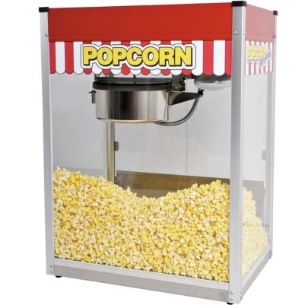
 | Cotton Candy  For 50 children | 1,100 EGP  For 75 children only. | 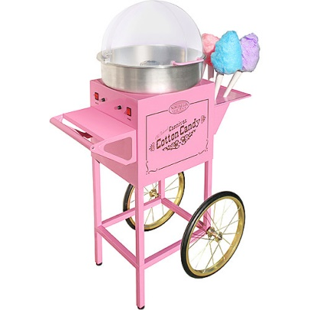
 | Children Tables & Chairs  1 Table & 6 chairs | 650 EGP | 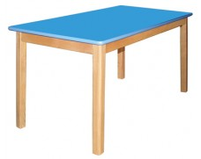
 | Sound Equipment  (must be added if the activities are part of the entertainment program or if the character meet & greet is chosen) | 1,850EGP | 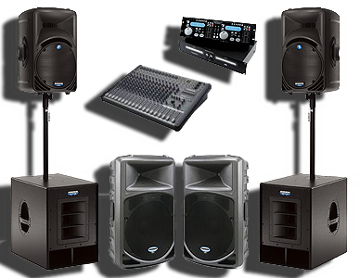
 | Photography  (client receives pictures on a USB stick or a CD, 2 weeks after the event date) | 2,500 EGP
 | Video Photography  (client receives a DVD with the video, 2 weeks after the event date) | 3,500 EGP | 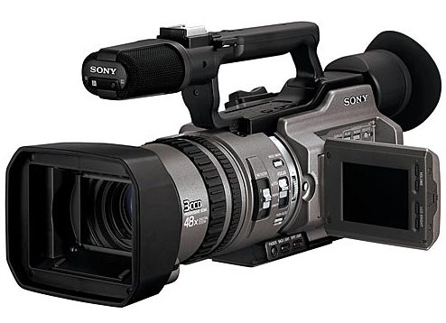

Save Money by choosing from the Saving Packages below!!!
Package | Package Description | Price
1 | Interactive Family Activities + Arts & Crafts Stations (25 children) | 13,720EGP
2 | Decoration Package  1 balloon arch with your choice of color  +  2 balloon stands with your choice of color  +  1 “Happy Birthday” banner with your Name printed on it (1.5 m x 1m) | 4,000 EGP
3 | Interactive Family Activities + Character Meet & Greet | 12,910 EGP
4 | A Bouncing Castle (no.6) + Live Circus Show | 5,150EGP
N.B Kindly add the sound equipment cost to the above prices if you choose packages which include Interactive Family Activities or Characters Meet & Greet.
Payment Terms
In case an event is booked 10 working days or more prior to the event date:
- 60% of the final quotation upon signing of this agreement.
- The remaining 40% is paid max. 48 hours before the event starts.
In case an event is booked in a period less than 10 working days from the event date:
- 100% of the final quotation upon signing of this agreement.
Payment is made to the Commercial International Bank – Egypt (CIB) under account details:
CIB Egypt
Swift Code: CIBEEGCX 127
Beneficiary's name: Blooms Egypt
Account Number: 1000 208 579 37 (EGP account)

For further information, please contact:

Blooms Egypt
24 Abou Gaafar El Nahas, Ard El Golf
Basement floor,
Heliopolis, Cairo, Egypt
Office: (+2) 02 2415 2411
Mobile: (+2) 0106 005 9828
Email: info@bloomsegypt.com
Website: www.bloomsegypt.com

